Guidelines for information extraction from pdfs – Raship
TEMPLATE 3 THREE
(LEAD EXAMPLE: 255613_AMERICO ROMERO SANABRIA.pdf)
General guidelines
Work with the excel templates in the folder "02_excel_templates"
Copy and paste the corresponding template and then change the name:
For example, when extracting the information from the pdf called "255613_AMERICO ROMERO SANABRIA ", use that name for the excel.
After finishing extracting the information:
Move/upload the excel file into the folder "03_clean_excel_files/template_3_THREE"
Move the PDF file from the folder "00_original_pdfs" into the folder "01_done_pdfs"
Use commas as thousand separators: Instead of writing 600.000 for example, you should write 600,000.

How to recognize template 3 THREE??
Template 3:
- Look for the titles of the sections 4, 5 AND 6
They are called “4. EGRESOS MENSUALES”, “5. INGRESOS MENSUALES” AND
“6. DECLARACION JURADA”:
Examples of 4,5 AND 6:
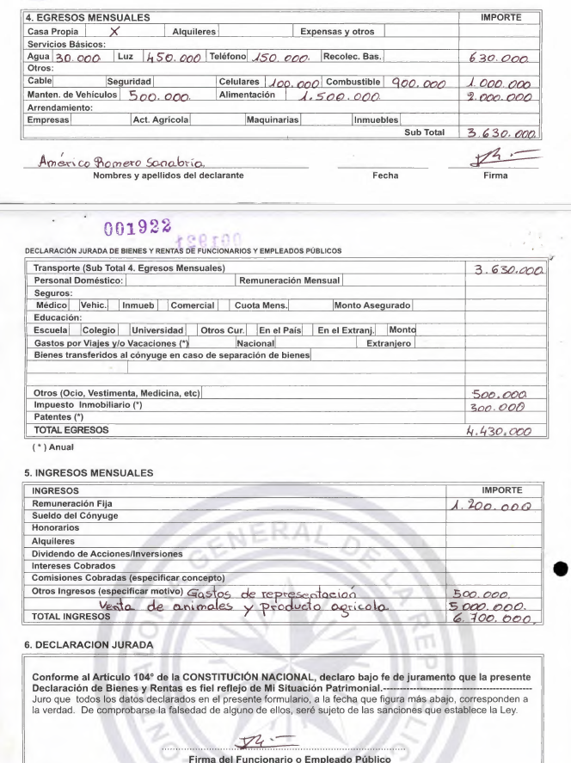

- Also, inside of the section “3. ESTADO PATRIMONIAL”, subsection “3.1 ACTIVO”, the rest of the headers DO NOT have numbers

Specific guidelines
1_datos_personales
- The first column "Marcar la casilla correspondiente" refers to this occasional appearance:

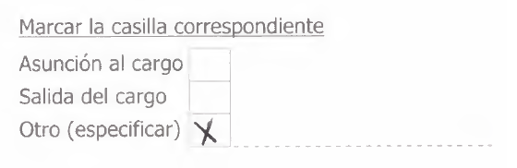

- The column "file_name" should be the name of the pdf with the extension at the end. For example:
255613_AMERICO ROMERO SANABRIA.pdf

- fecha_dia_mes_ano:
If this information is blank:
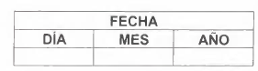
Look for a STAMP or SEAL or HANDWRITE at the top of the page, and input the date there, example:
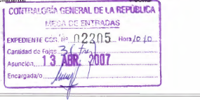
Would be inputted as 13/04/2007 (format of date in South America is DAY/MONTH/YEAR so careful with that)

Notice here there are a bunch of dates in the format of seals and handwriting. In case they do not match, you can ask me and I’ll take a look at it.

- If some variables (columns) are blank in the pdf, leave them blank in the excel.

2_informacion_laboral

- The third column in this sheet is called "tipo de funcionario(nombrado,electivo,otros)" and sometimes it doesn't show up. But when it does, it shows up like this:

- "cargo_o_funcion" and "categoria de funcionario" are TRICKY SOMETIMES. If they didn't write anything, you can check what they have underscored or selected here:
(In this case, you should input the word "Intendente" both in "cargo_o_funcion" and "categoria de funcionario", unless there was already something written there.)

3_1_1_efectivo_y_depositos

3_1_2_cuentas_a_cobrar

3_1_3_inmuebles
3_1_4_vehiculos

3_1_6_ganado
You can leave the importe column here blank.

3_1_7_acciones_inversiones_bono

3_1_8_muebles

3_otros_activos

3_2_pasivo

3_3_resumen

4_egresos_mensuales
- Careful here with the columns. I’ve created 4 columns in the excel template:
Notice that the second column is called white_box and the third one is called importe. Those are the only 2 columns you have to fill:

white_box:
where you should input the numerical value right next to the letters

importe:
where you should input the value you see on furthest right column in the pdf.

Do not modify the column called “anual”.

- Do not include partial sums. Those are the values in the importe column that says ``Sub Total". Just ignore that number.
Example of the last two bullet points:
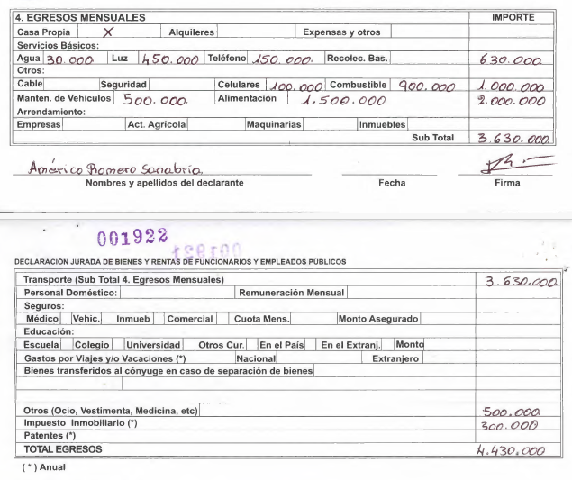

Translates to this:
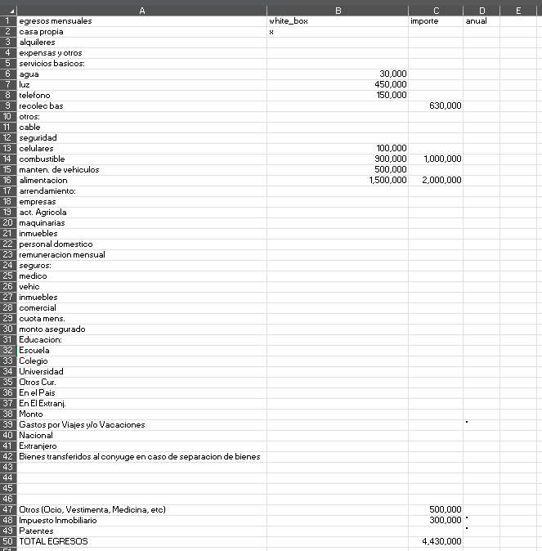

(see how there is not a Sub total row nor the value 3,630,000 inputted)

5_ ingresos_mensuales
Careful with the column in the middle, the one called “type”. Here goes whatever it’s handwritten. The numbers go in importe.

6_declaracion_jurada

- Check what is the name on top of the words "Escribano Publico", in the SEAL. Sometimes it can say ``Notario" or ``Notaria"
EXAMPLE:
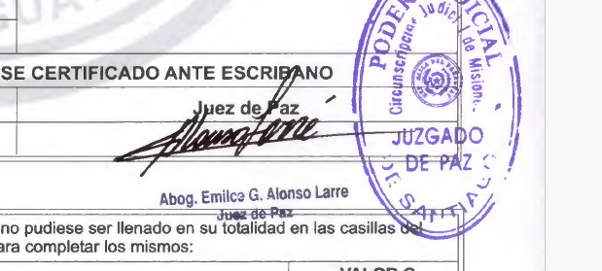
Sometimes you will not find anything there, neither for escribano public nor observation. But most of the time I think you will find some seal with the word escribano or “ABOG” there. (In this case you should write “Abog. Emilca G. Alonso Larre”)

Observacion
If this is blank, leave it blank.
If it has information, write “see pdf”

